

**Dynamics 365 – Trade Agreement Journals**

**Revision 1**

**Revision History**

|  |  |  |  |  |
| --- | --- | --- | --- | --- |
| **Date** | **Revision** | **Description** | **Signature / Date** | |
| 05/04/2022 | 1 | Initial draft of user manual: Trade Agreement Journals | Prepared | Salman Tahir |
|  |  | Verified |  |
|  |  | Approved |  |
| 19/12/2022 | 2 | User manual: Trade Agreement Journals | Prepared | Waseem Abbas |
|  |  | Verified |  |
|  |  | Approved |  |
|  |  |  | Prepared |  |
|  |  |  |  |
|  |  |  |  |
|  |  |  |  |  |
|  |  |  |  |
|  |  |  |  |

**Table of Contents**

1 About User Manual 5

2 Dynamics 365 – Trade Agreement Journal 5

2.1 New Trade Agreement Journal 6

2.2 Trade Agreement for Specific Vendor 8

2.3 Generating Trade Agreement Lines 10

2.4 Trade Agreement Journal Lines 11

2.5 Expiry of Trade Agreement Journal 12

2.6 Multiple Lines per parts 13

2.7 Download Trade Agreement Lines 14

3 Generate Specific Trade Agreement Lines 15

List of Figures

Figure 1 Vendors from Procurement and Sources 5

Figure 2 All Vendors List 5

Figure 3 Open the Trade agreement 6

Figure 4 Trade Agreement Journal Page 6

Figure 5 Trade Agreement Journal Lines 6

Figure 6 No Active Search Dimension 7

Figure 7 Active Dimension after adding the item 7

Figure 8 Added the Same Item in the Journal 8

Figure 9 Select to find trade agreement 8

Figure 10 Popup to Find the Trade Agreement of Vendor 9

Figure 11 Process Alert After sending Request to Find Trade Agreement 9

Figure 12 Success Message to find the Trade Agreement of Vendor 10

Figure 13 Generating Trade Agreement Journals 10

Figure 14 Trade Agreement Journal Criteria 11

Figure 15. Trade Agreement Journal Lines 11

Figure 16 Expiration of the Trade Agreement Journal 12

Figure 17 Expiration of Trade Agreement Journal 12

Figure 18 Multiple Lines per parts Popup 13

Figure 19 Multiple Lines per Parts 13

Figure 20 Download Trade Agreement Journal Lines 14

Figure 21 Download to Export in Excel file 14

Figure 22 Trade Agreement Journals in Excel file 15

Figure 23 Trade Agreement for specific Criteria 15

Figure 24 Trade Agreement Lines 16

# About User Manual

In this manual, it will be briefed about creating trade journal lines for all items or specific items. The trade agreement lines give information about the items price and other related information.

# Dynamics 365 – Trade Agreement Journal

In order to create a new vendor, select the modules option. Go to the Procurement and Sourcing and select ‘**All vendors**’ available under the Vendor sub-option.

**Navigation**: Modules> Procurement and Sourcing > Vendors > All vendors

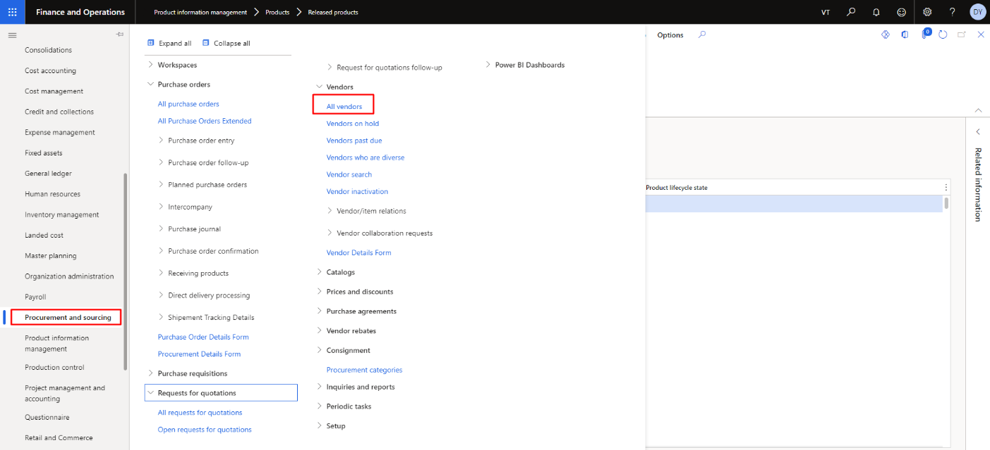

Figure 1 Vendors from Procurement and Sources

In the below list, user can see the all the vendors. The user needs to click on vendors to open it.

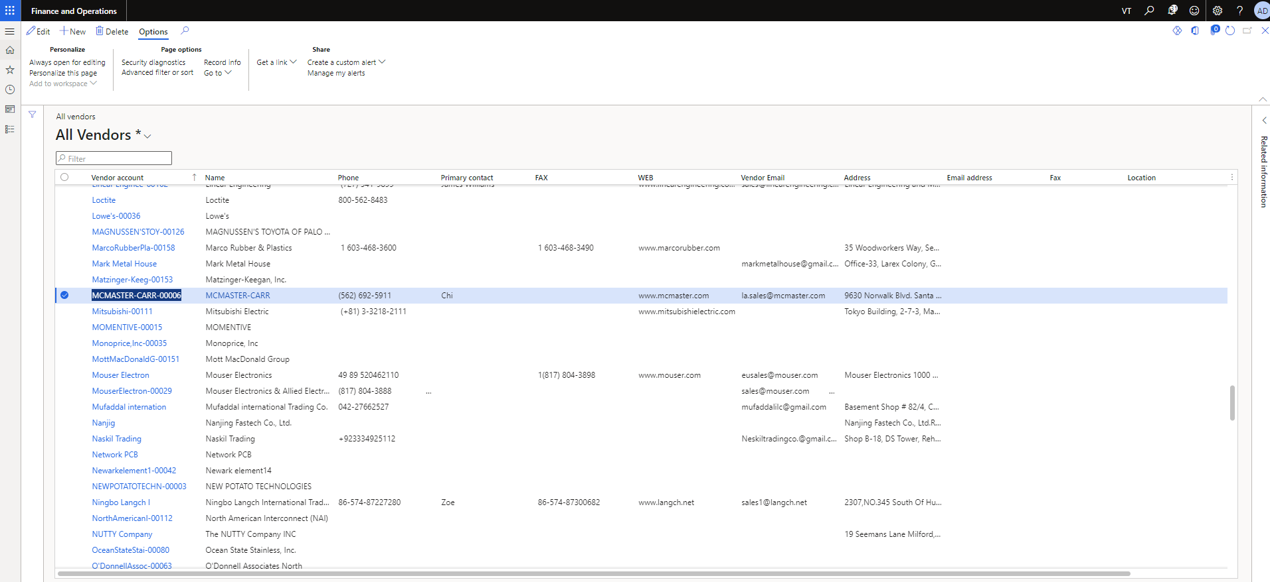

Figure 2 All Vendors List

The user needs to click on Trade agreement from the Agreement dropdown in New tab.

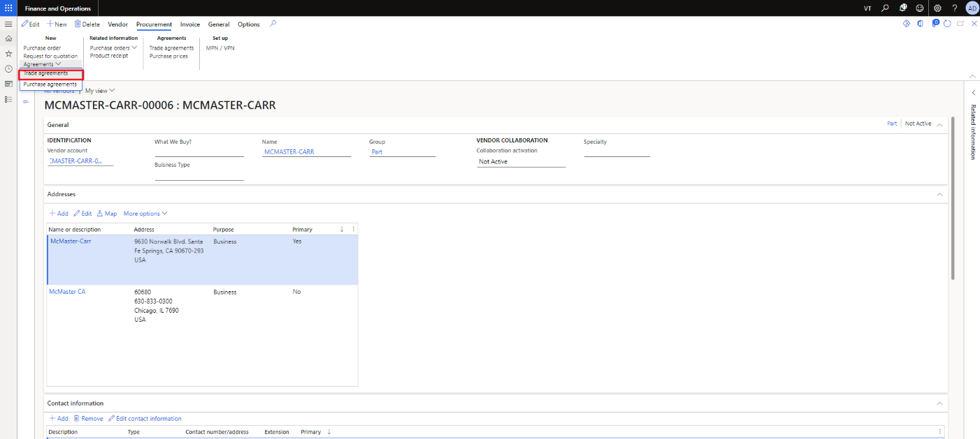

Figure 3 Open the Trade agreement

On the trade journal page, all journals will be visible.

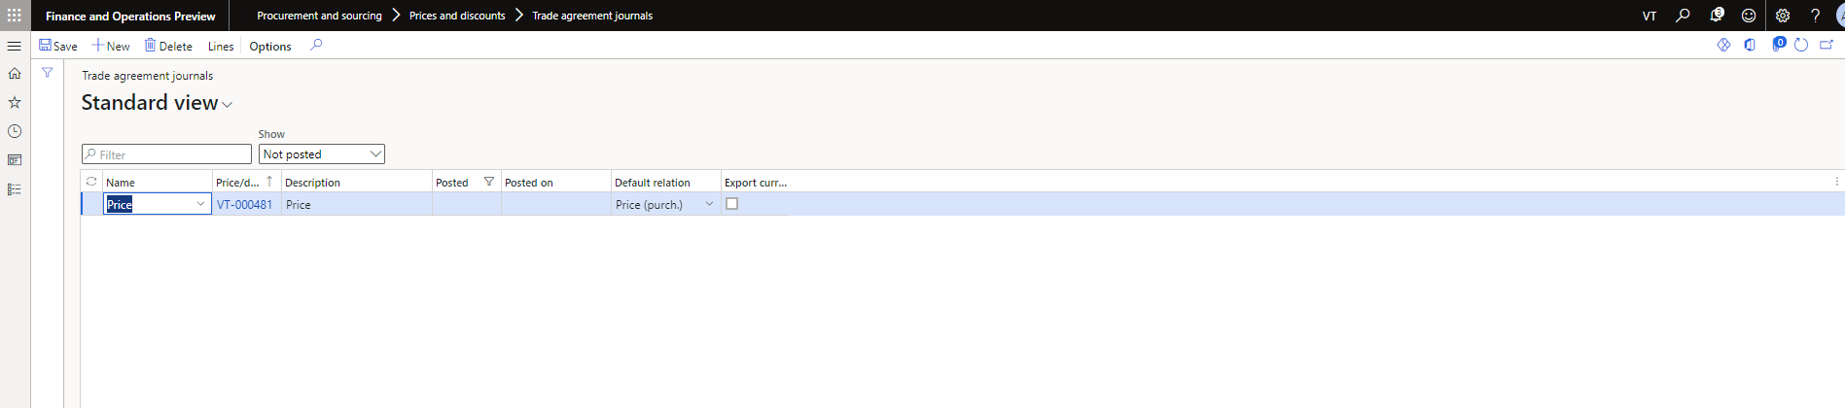

Figure 4 Trade Agreement Journal Page

## New Trade Agreement Journal

New trade line will be created when you press ‘**New’** option available on top. After entering name and description for journal. Press the ‘Lines’ option available on the top. The line option is used to give description about the journal.

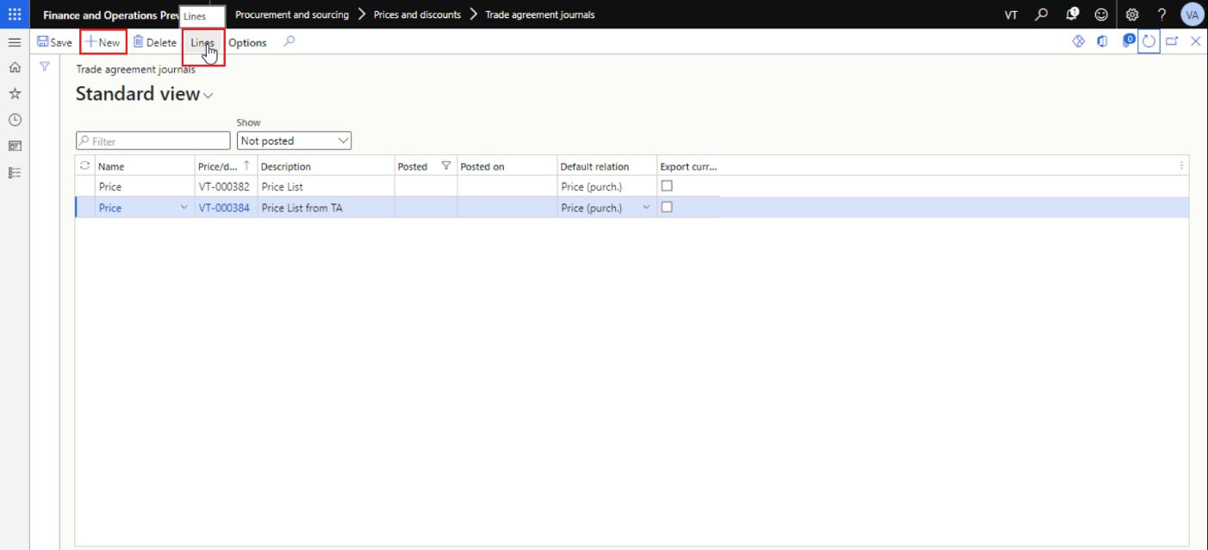

Figure 5 Trade Agreement Journal Lines

The user will see the screen after opening the specific journal. The user needs to Account and item number with its REV to create the trade journal. In the trade journal user can also add the amount and unit amount. In the below Figure, there is no active dimension of the journal due to unavailability of item with its properties.

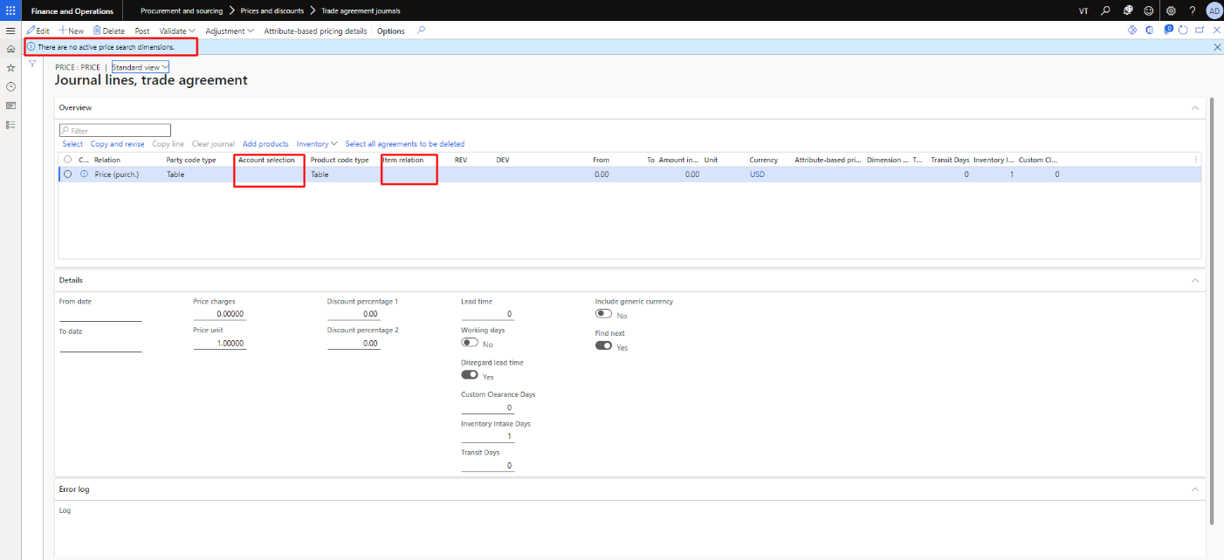

Figure 6 No Active Search Dimension

The user can see the active search dimension in the below image after adding the item.

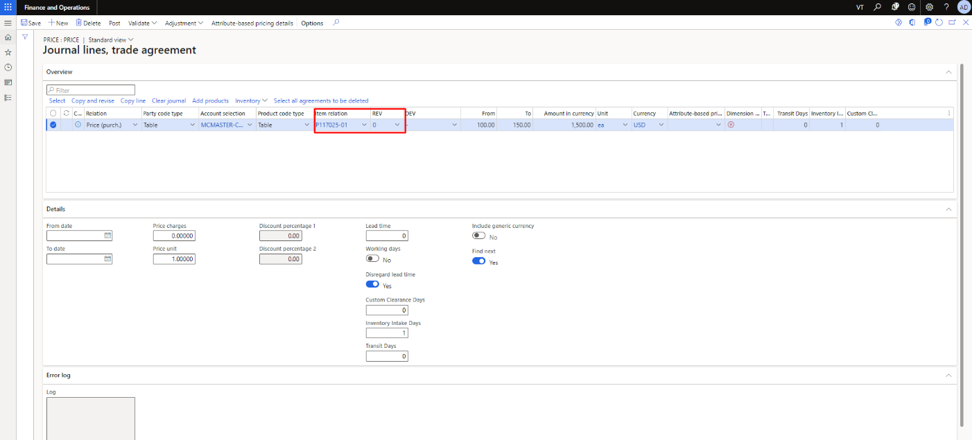

Figure 7 Active Dimension after adding the item

The user can also add the same items to create the journal of it.

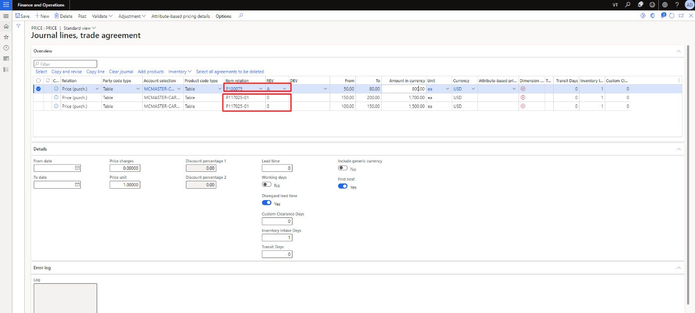

Figure 8 Added the Same Item in the Journal

## Trade Agreement for Specific Vendor

The user needs to open the any trade agreement journal by clicking on line to find the trade agreement of the specific journal. As the user open the trade agreement then click on select. The user needs to fill the fill the popup fields (select table, vendor and customer relations) and click on select button.

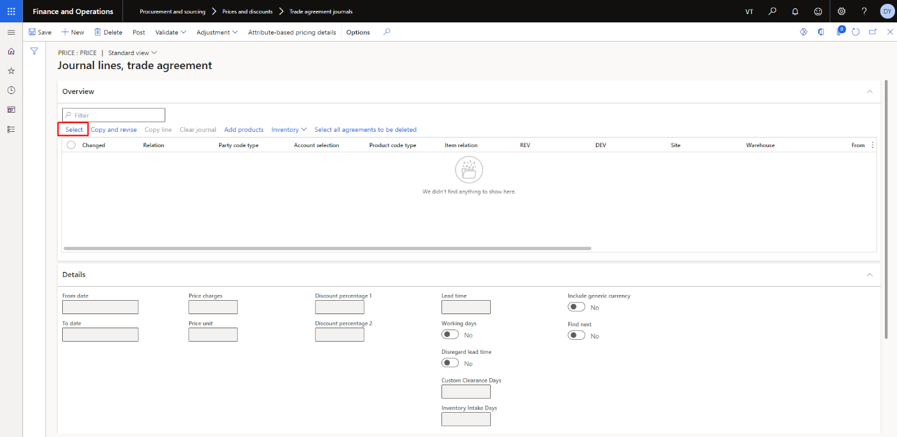

Figure 9 Select to find trade agreement

The user needs to select any relation, customer relation and vendor then click on select button

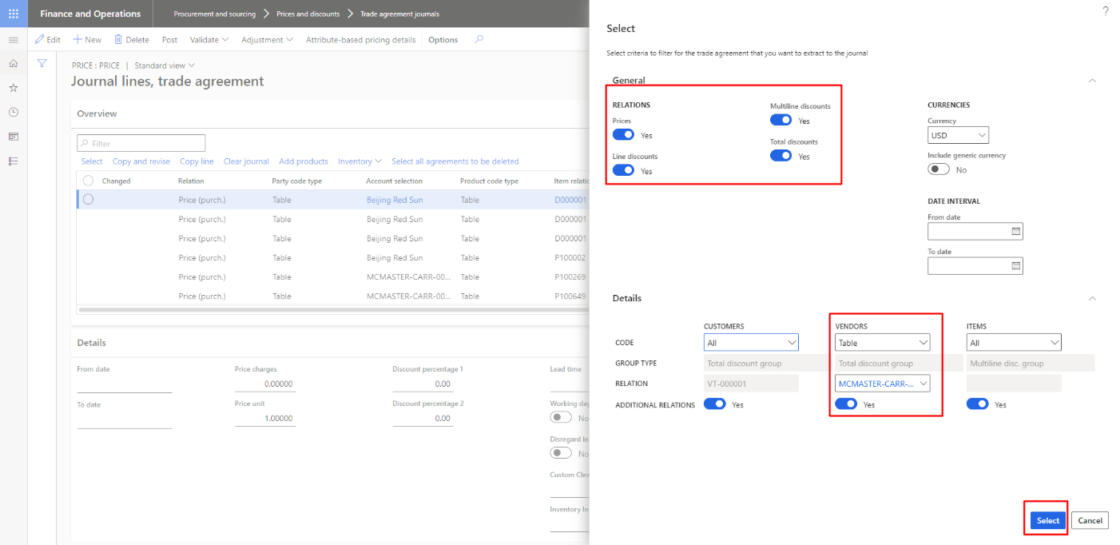

Figure 10 Popup to Find the Trade Agreement of Vendor

As the user click on select process alert will show

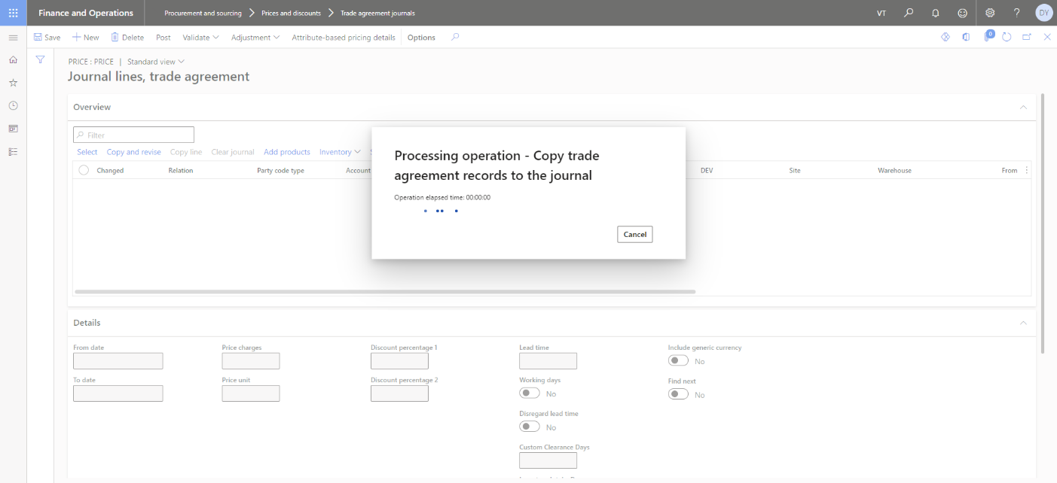

Figure 11 Process Alert After sending Request to Find Trade Agreement

The success message will show to user after getting the data successfully.

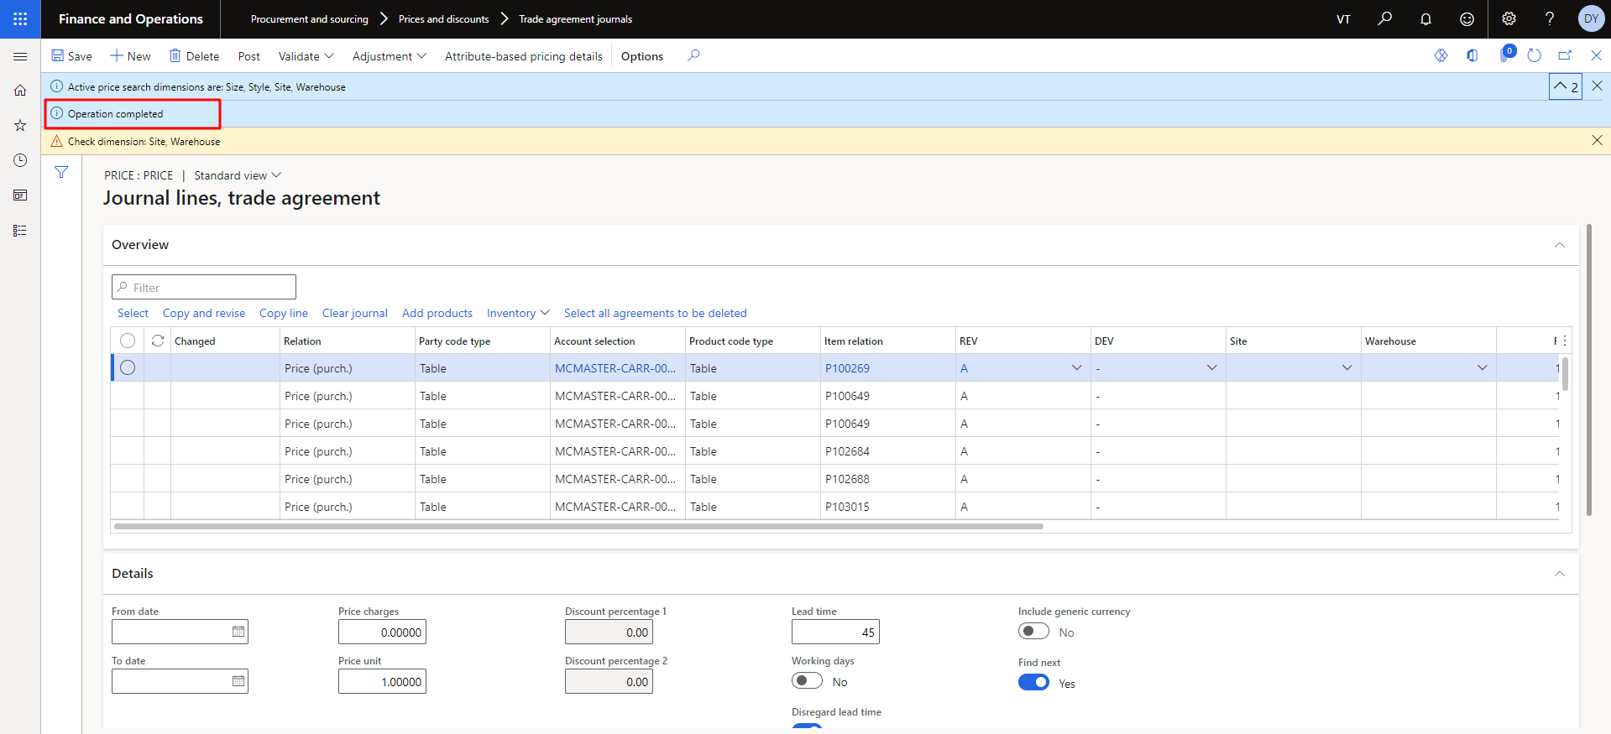

Figure 12 Success Message to find the Trade Agreement of Vendor

## Generating Trade Agreement Lines

In order to generate trade agreement lines, click on the ‘**select’** option as shown in figure.

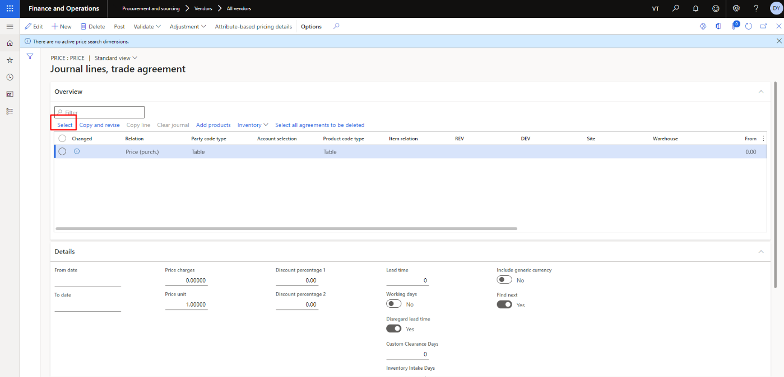

Figure 13 Generating Trade Agreement Journals

Enter the useful details in the dialog box that appears.

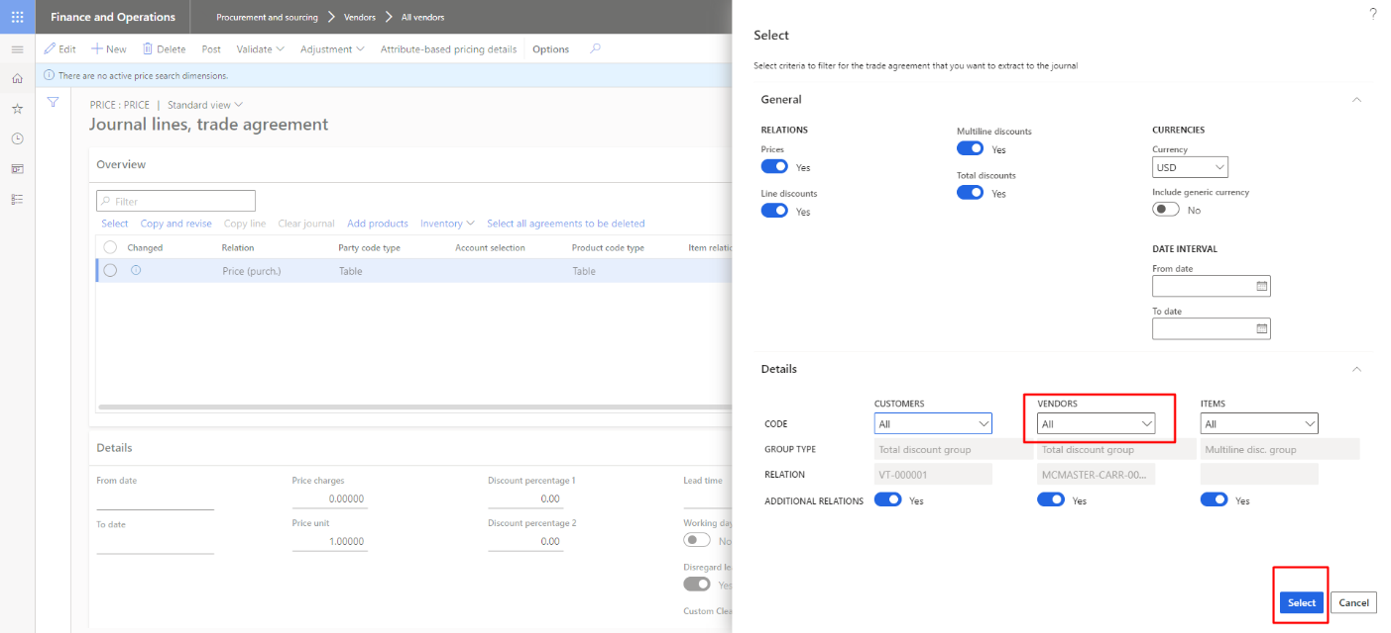

Figure 14 Trade Agreement Journal Criteria

## Trade Agreement Journal Lines

The trade agreement for all line items will appear after previous step. For each line item, information like relation, lead time, quantity, currency etc. will be visible.

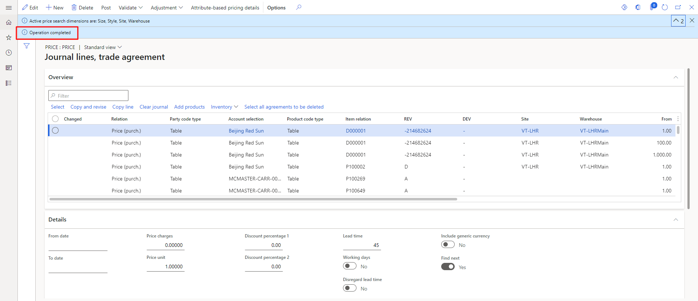

Figure 15. Trade Agreement Journal Lines

## Expiry of Trade Agreement Journal

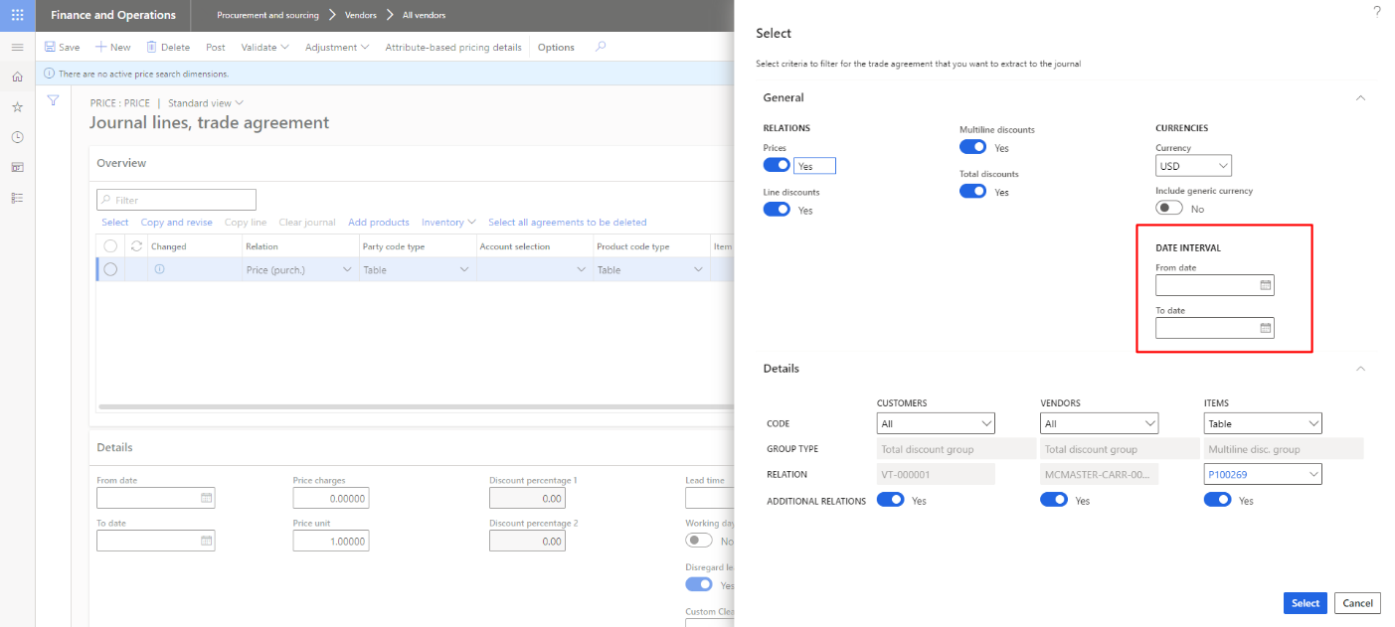

Figure 16 Expiration of the Trade Agreement Journal

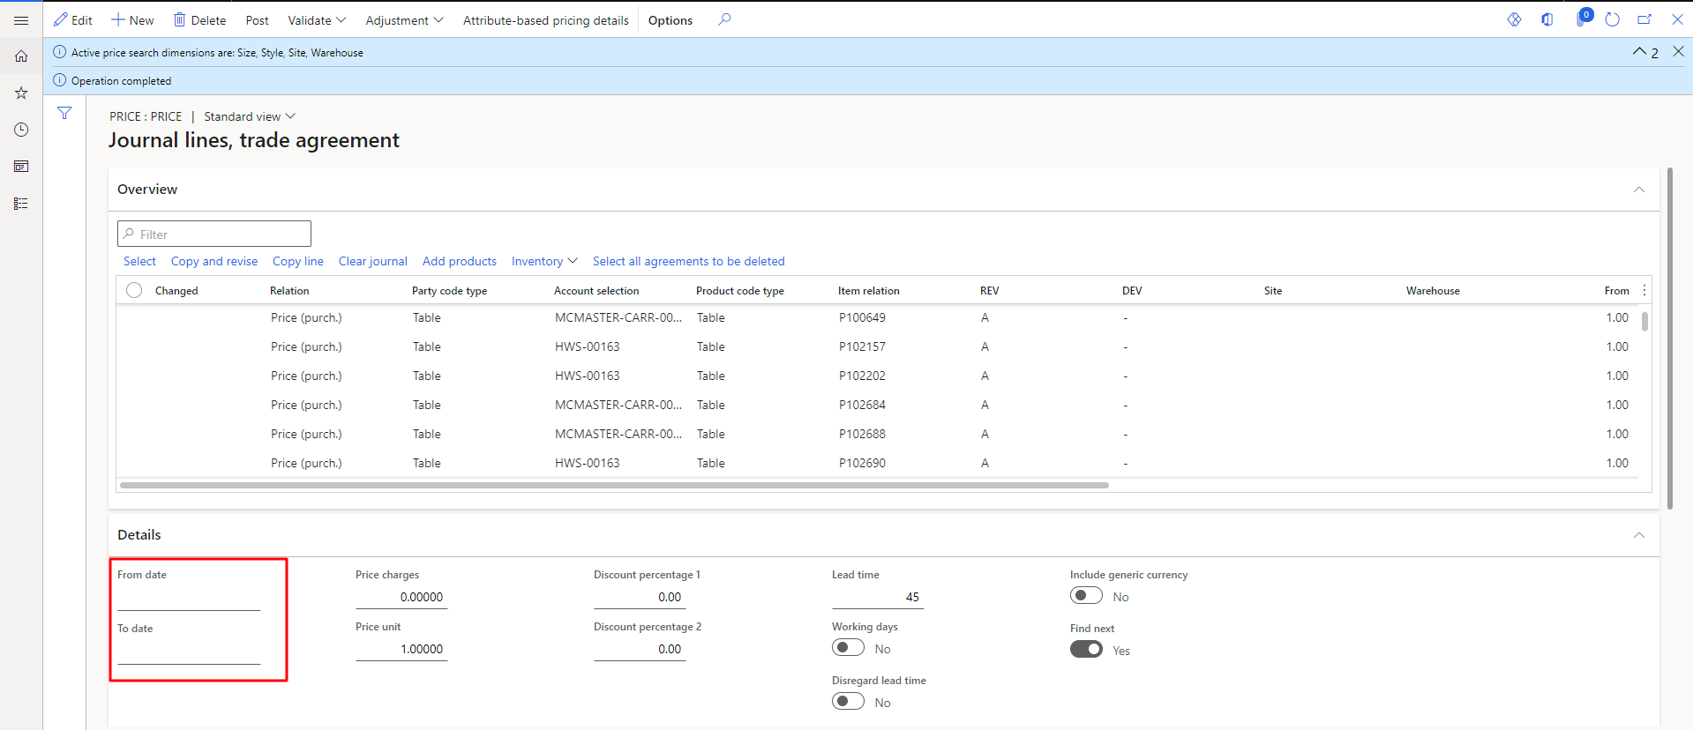

Figure 17 Expiration of Trade Agreement Journal

## Multiple Lines per parts

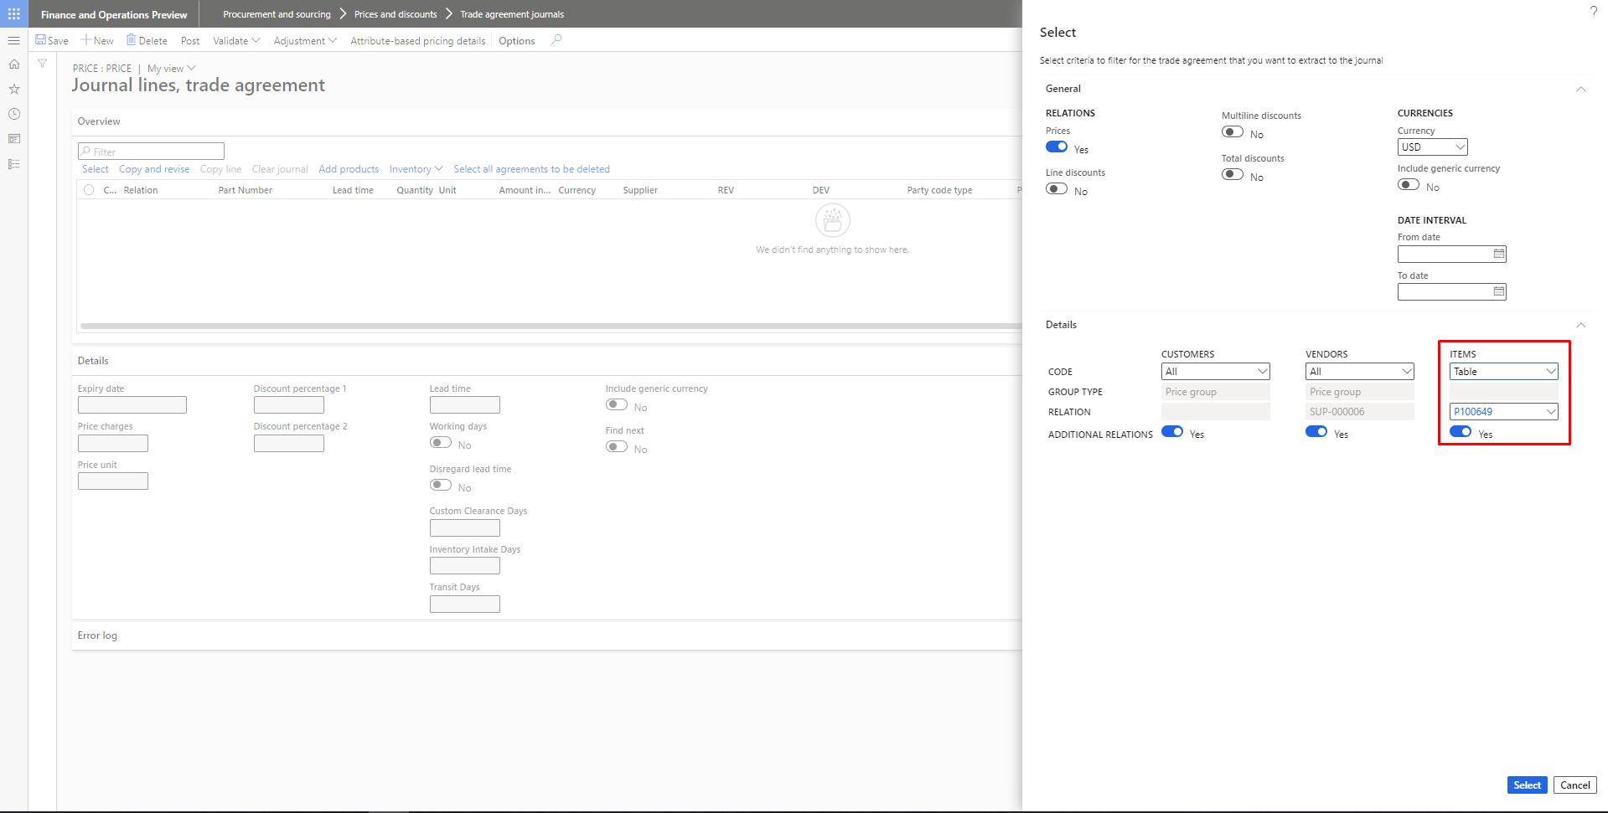

Figure 18 Multiple Lines per parts Popup

The user can see that multiples items in the lines.

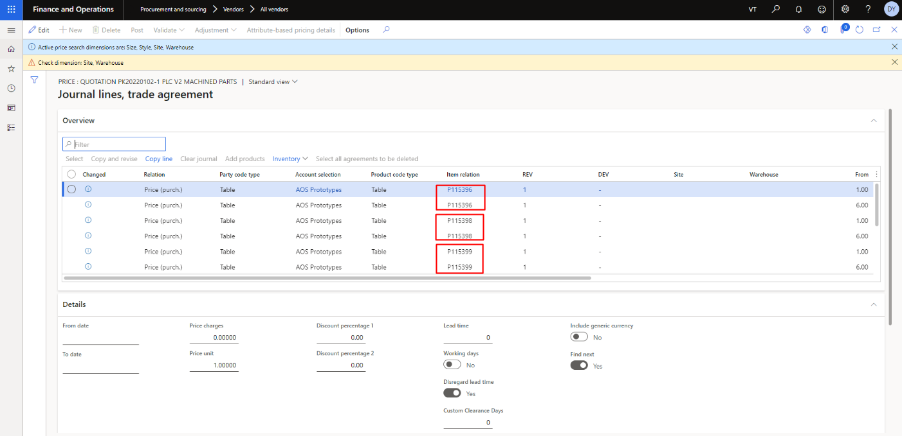

Figure 19 Multiple Lines per Parts

## Download Trade Agreement Lines

To get this data for record, download all the data in excel format.

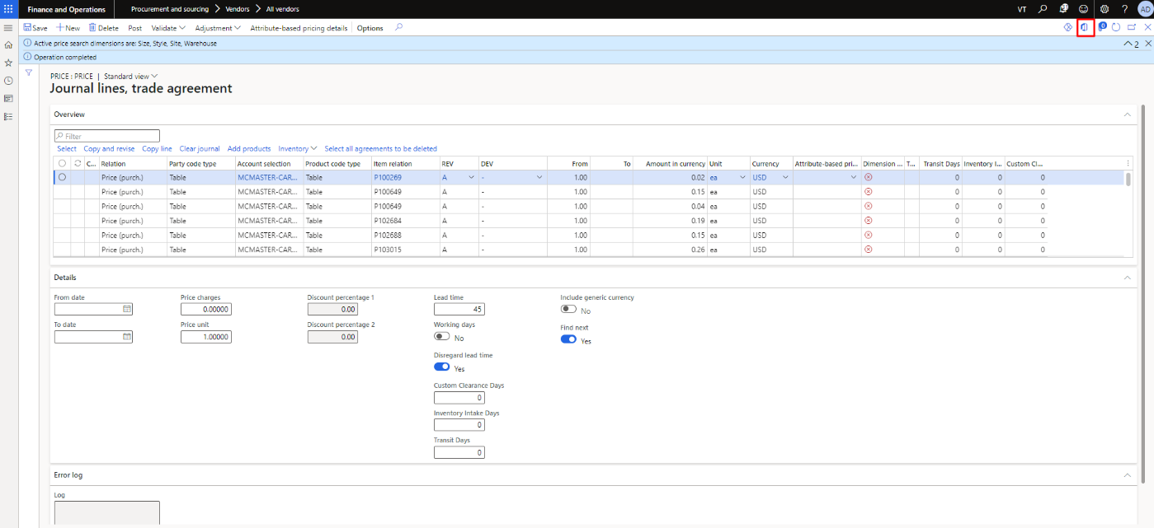

Figure 20 Download Trade Agreement Journal Lines

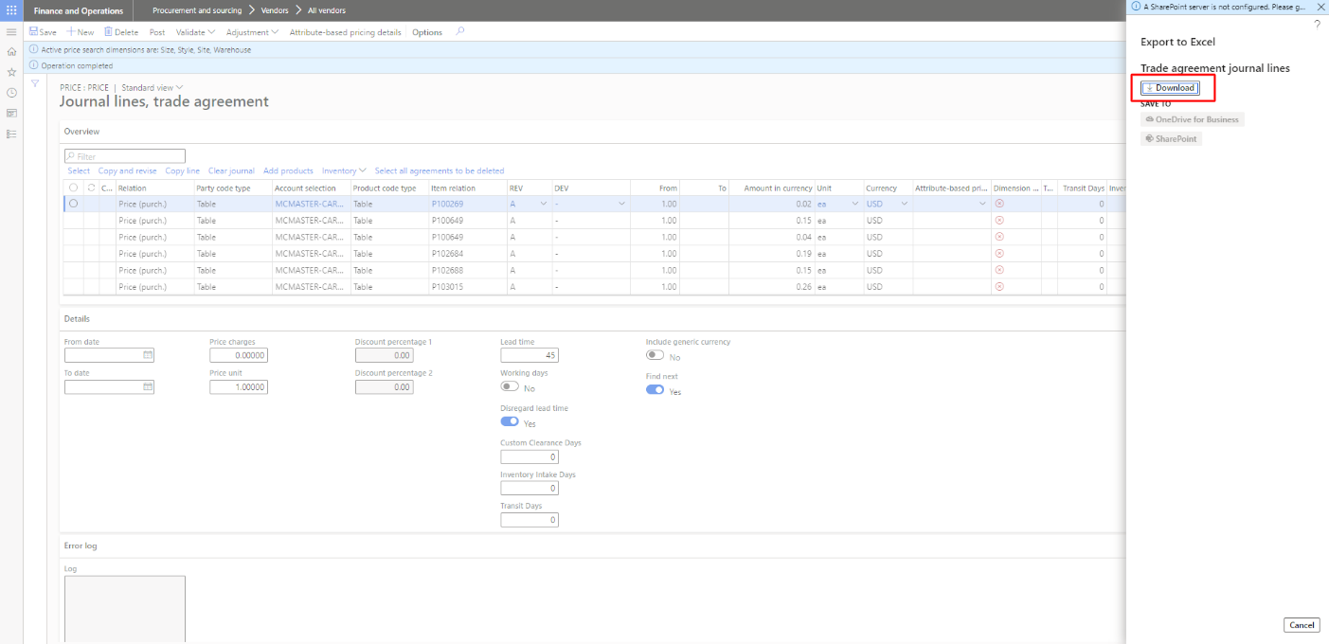

Figure 21 Download to Export in Excel file

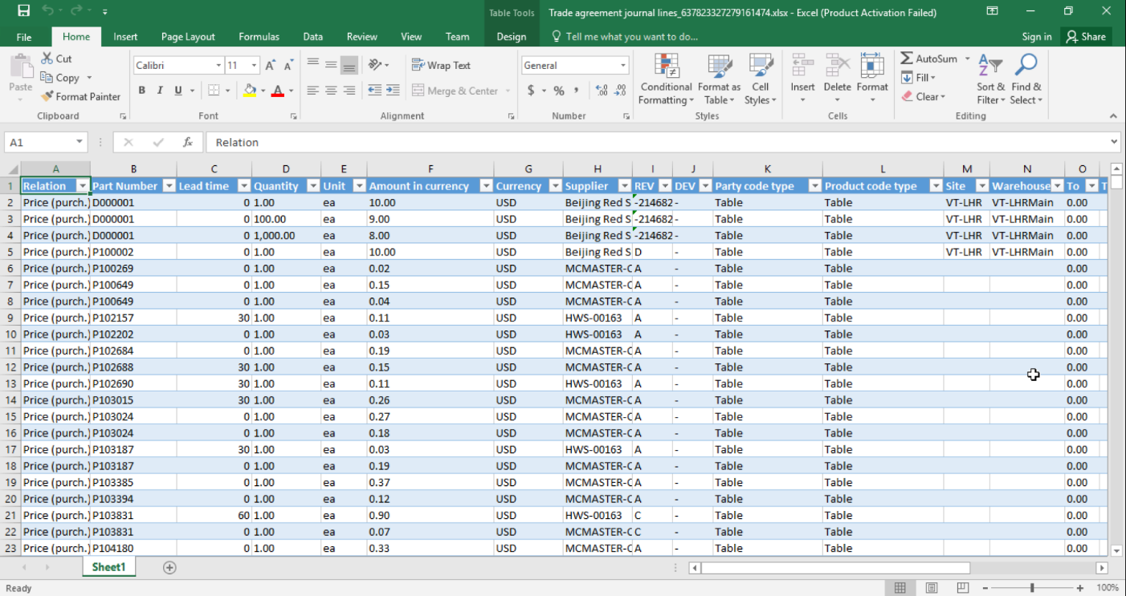

Figure 22 Trade Agreement Journals in Excel file

# Generate Specific Trade Agreement Lines

In order to generate trade agreement journals for specific items enter the item name as shown in figure below.



Figure 23 Trade Agreement for specific Criteria

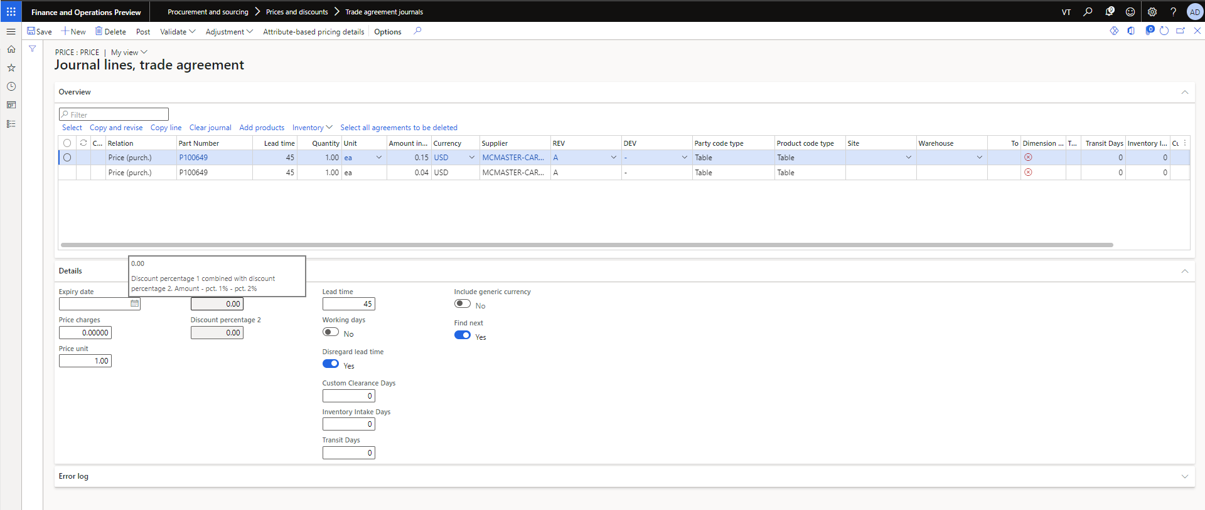

Figure 24 Trade Agreement Lines